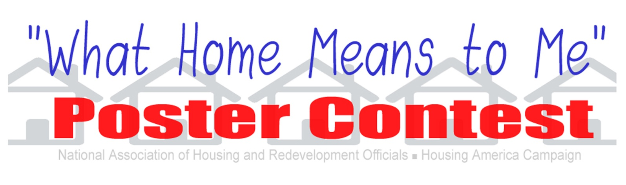
Now accepting poster entries from children K-12 being served by the Boise City/Ada County Housing Authority until March 15th, 2018.
Each year the National Association of Housing and Redevelopment Officials (NAHRO) holds a poster contest as part of their Housing America Campaign. The theme is “What Home Means to Me” and is an opportunity for youth grades K-12 residing in any one of the Boise City/Ada County Housing Authority’s programs to be selected for regional and national recognition for their artwork. This contest is a result of collaboration on a local, state, and national level; national honorees are selected from state level winning entries.
Poster Specifications:
- Theme - "What Home Means to Me"
- Size – All posters must be 22” x 28” to be considered for national judging.
- Media - Contestant may use any art media (marker, crayon, paint, collage, textiles, etc.), but please consider that posters will need to be packaged, mailed and reproduced.
- All entries must be mailed flat.
- All contestants must sign a release making their entry the property of NAHRO and permitting duplication/publication thereof. The release should be secured to the back of the entry.
- All contestants are asked to provide a short narrative on the inspiration, vision and importance of their poster design. The narrative should be secured on the back of the entry.
- Contestants name, grade level and housing authority must be written on the back of the each poster entry in addition to being listed on the release form also attached to the entry.
- NAHRO is only responsible for returning the original poster to the national grand prize winner. NAHRO is not responsible for returning poster unless otherwise contacted by October 1.

See Attached Entry Rules, Details, and Application
National Honorees will be selected and announced during Housing America Month in October. All eight NAHRO regions will be represented in the 2019 “What Home Means to Me” calendar. The 12 national winners will each receive a $100 Visa gift card. The national grand prize winner will be awarded an iPad. The grand prize winner and one member of his or her family will also be provided with transportation to and from and lodging at NAHRO’s Washington Conference in Washington, D.C. where he or she will be honored. The grand prize winner will also receive a framed copy of their original artwork and will tour Capitol Hill.

ALL SUBMISSIONS MUST BE RECEIVED NO LATER THAN MARCH 15, 2018!!
Please submit to:
Boise City/Ada County Housing Authority
1276 River St Suite 300
Boise, ID 83702

For any questions or more information, please contact one of the following:
Frances (208) 287-1045 Jae (208) 287-1060
Sharon (208) 287-1059 Sonja (208) 287-1079

