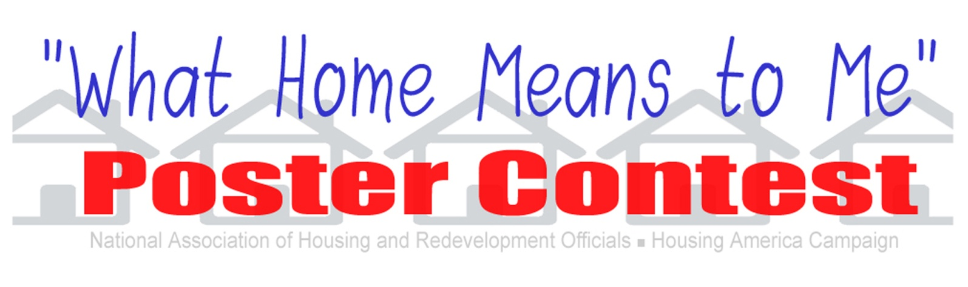
"What Home Means to Me"
Please write a short paragraph (100 words or less) explaining your poster.

